**Determining Possible Component Dimensions**

This document extends the ideas in 3: Required Hardware for Prototype Function by determining the dimensions of each component that was found to be needed for basic machine function.

Known Constraints with Quantitative Values:

The allowable dimensions of the washing machine is limited by the dimensions of the ISS EXPRESS Locker, which has a width of 17.34”, a height of 21.10”, and a depth or length of 21.45”. The locker does have chamfers along the depth of the box, but they will be ignored with the assumption that they can be accounted for later on in the design to simplify the design process.

Other factors that directly affect the dimensions of the design are the volume of water and volumes of clothing that need to be accommodated for. In this case, the max allowed use of water is 500 mL of water, and using a T-shirt as the clothing item to be washed, the clothing has a volume of 150 mL of water, which was found by submerging a sample completely and finding how much water is displaced.

Wash Chamber Bottom Dimensions:

By design, the wash chamber is just big enough to hold the allowed amount of water, 500 mL, and a shirt, which has a volume of 150 mL (though it occupies the entire space of the water fluid mixture uncompressed). This means the minimum capacity of the wash chamber is 650 mL to wash a T shirt. Since ideally the washing machine keeps air and water separate, this is also the maximum capacity of the wash chamber.

Capacity of Wash Chamber = 650 mL

While this volume will change as clothing types and sizes are used, for now, only T-Shirts are taken into account for simplicity of design and testing.

Knowing that the wash chamber is cylindrical, the equation for the volume of a cylinder

( $V=πr^{2}h$) can be used to find the possible heights and diameters for the chamber. The equation can be rewritten as $D=2√((V/16.387)/πh)$, or $D=2√((V/16.387)/πh)$, where $D=2r$ and 16.387 is the unit conversion from milliliters to cubic inches.

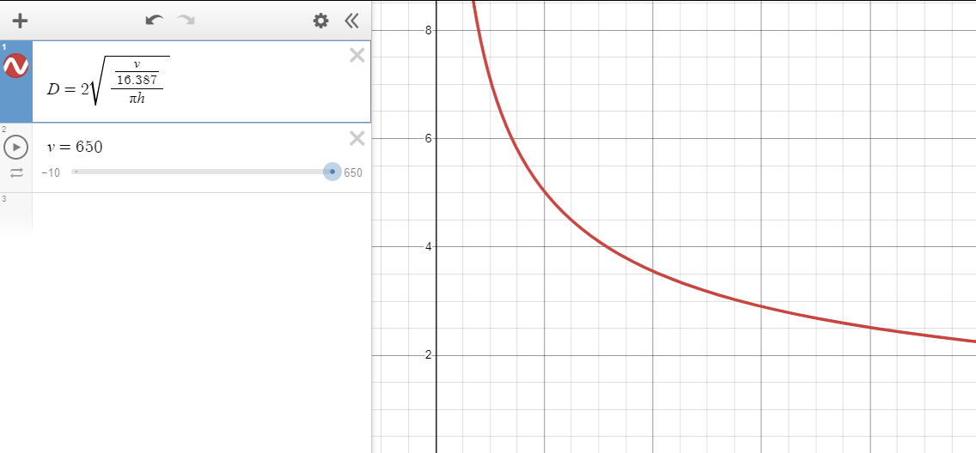

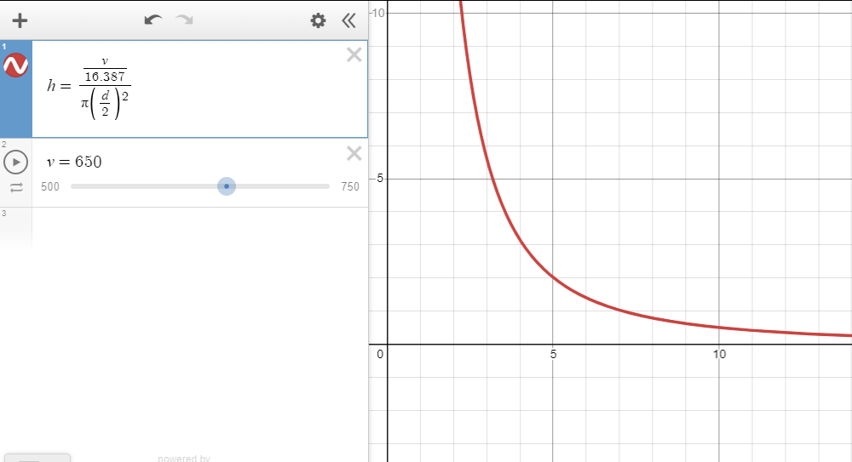

These equations only provide possible dimensions for the wash chamber at this volume. Picking what dimensions to actually use comes down to what materials are available and accommodating the other goals of the design. Considering that the machine is to fit size constraints for a spaceship, the wash chamber cannot be too tall, as the height in even the most ideal conditions is twice that of the piston travel. Additionally, it can be reasonably assumed that the clothing item will be harder to compress at the extremes of either the height or diameter. Part of the wash plan for agitating the clothing item includes using the high velocity flow of water to reorient the clothing item and dislodge solid contaminants. Knowing this, we know we are looking for something with a roughly similar height and diameter. Both dimensions are roughly equal at approximately h = 3.7. Looking at available materials, PVC Pipe comes in diameters of 3.5 inch and 4 inch. For this design, we will be looking at a 4 inch PVC Pipe, since it is easiest to make a piston head for this size.

Approximating Chamber Top Travel:

As established in *3: Required Hardware for Prototype Function*, there is a change in volume of the chamber due to the insertion of the shaft into the wash chamber as the piston is compressing clothing. To quantify this change in volume, the cross sectional area of the shaft can be multiplied by the total distance of piston travel from fully retracted, represented by $V=πr^{2}T$.

*Note: equations cited in this segment use variables r, R, t, and T, where r = Radius of Shaft, R = Radius of Wash Chamber, t = Chamber Top travel, T = Piston travel distance, and V = Volume*

When the chamber top extends upward, it increases the volume of the chamber by the cross sectional area of the wash chamber minus the cross sectional area of the shaft multiplied by the distance traveled, represented by $V=t(πR^{2}-πr^{2})$.

When the volume displaced by the piston head and the volume created by the chamber top moving are equal, the resulting volume is equal to the initial, shown as $πr^{2}T=t(πR^{2}-πr^{2})$. With this equation, any variable could be solved by knowing the other three, but most values aside from the required chamber top travel will be known. Solving for t, the result is $t=πr^{2}T/(πR^{2}-πr^{2})$ which can be simplified to ${t=r}^{2}T/(R^{2}-r^{2})$.

Approximating Allowable Piston Travel:

The entire washing machine is designed around the wash chamber. Getting the maximum possible piston travel and corresponding chamber height is important for the machine's capability to wash clothing of varying sizes and types. Since the chamber top is made to move, having a greater capacity than needed can be reduced as needed for a given load, meaning the washi chamber being too long cannot hurt the operational capabilities of the machine.

*Note: For the equations derived, variables include H, r, R, t, T, and W, where $H{}_{Max}$ = Max allowable height of machine, r = Radius of Shaft, R = Radius of Wash Chamber, t = Chamber Top travel, T = Piston travel distance, and W[component] = Width of component in washing machine.*

With the acting piston fully retracted, the shaft will protrude out of the wash chamber. This means that ignoring all structural and mechanical components, the maximum the piston travel can be with an ideal design is half of the area left over, represented by $T=H{}_{Max}-T$. This equation could be seen as the ideal max allowable piston travel. While this is a good start, there are a number of other things that need to be considered to estimate the actual expected max piston travel.

In an ideal world, structural components have no thickness, but since a great deal of force needs to be applied in order for a clothing item to be adequately compressed, structural components must have some thickness in order for the machine to have rigidity. In order for the maximum piston travel to be as high as possible, it is important that these components are as thin as possible to accommodate the expected load. The max allowable piston travel is defined by the maximum allowable length of the machine minus the thickness of each component in line with the piston head. Inserting that into the previous equation, this can be represented by $T=H{}_{Max}-(T+∑W)$.

As shown in *3: Required Hardware for Prototype Function*, and further explored in this document, as the Piston is extended to compress clothing items, the Chamber Top needs to be made to move proportionally such that the Wash Chamber maintains a constant volume. This can be shown by just subtracting the Chamber top movement, which was found to be ${t=r}^{2}T/(R^{2}-r^{2})$, from the max allowable height, represented by $T=H{}_{Max}-(T+ t+∑W)$, substituting t for ${(r}^{2}T/(R^{2}-r^{2}))$, the equation can be represented as $T=H{}_{Max}-(T+ {(r}^{2}T/(R^{2}-r^{2}))+∑W)$. With this, the equation for estimating max piston travel has been found.

While this shows a proportion between the max allowable piston travel, it is clear to see that the piston travel is defined in part by the max allowable piston travel. While this is the case, what it does show is a proportion of various aspects of the washing machine to the piston travel, which using algebra could be used to determine an equation that can estimate the max piston travel without already knowing it.



$T=H{}_{Max}-(T+ {(r}^{2}T/(R^{2}-r^{2}))+∑W)$

Distribute negative sign across $(T+ {(r}^{2}T/(R^{2}-r^{2}))+∑W)$

$T+T+ {(r}^{2}T/(R^{2}-r^{2}))=H{}_{Max}-T- {(r}^{2}T/(R^{2}-r^{2}))-∑W+T+ {(r}^{2}T/(R^{2}-r^{2}))$

Separate all instances of T to one side of equation

1. $2T+{(r}^{2}T/(R^{2}-r^{2}))=H{}_{Max}-∑W$, $2T= 2T(R^{2}-r^{2})/{(R}^{2}-r^{2})=2TR^{2}-2Tr^{2}/{(R}^{2}-r^{2})$

Put $2T$ in terms of a common denominator to add to ${(r}^{2}T/(R^{2}-r^{2}))$ to be added

$2TR^{2}-2Tr^{2}/{(R}^{2}-r^{2})+{(r}^{2}T/(R^{2}-r^{2}))= T(2R^{2}-r^{2}/(R^{2}-r^{2}))=H{}_{Max}-∑W$

Simplify equation and use distributive property to get one instance of $T$ in equation

$T(2R^{2}-r^{2}/(R^{2}-r^{2}))=H{}_{Max}-∑W$

Divide both sides of function by $(2R^{2}-r^{2}/(R^{2}-r^{2}))$ to solve for $T$

$T=(H{}_{Max}-∑W)/(2R^{2}-r^{2}/(R^{2}-r^{2}))=(H{}_{Max}-∑W)(R^{2}-r^{2}/({2R}^{2}-r^{2}))$

Solution: $T=(H{}_{Max}-∑W)(R^{2}-r^{2}/({2R}^{2}-r^{2}))$

This function is great for approximating the feasibility of this approach for any given size constraint since if the output height is less than the previously defined dimensions of the wash chamber, the conclusion can be made that the space cannot accommodate the linear space needed for the machine. Additionally, the limits of how narrow the wash chamber can be can also be found using this equation, as one of the variables of the equation is the wash chamber radius. This equation will also be referenced again after the dimensions for each of the other components are found so that the length of the chamber as a whole can be found as well as the maximum volume of the wash chamber can be found.

To check this equation, a mix of given and assumed values can be imputed into the equation, and if the sum of the values that make up the height of the machine is equal to the maximum allowable height, then the equation is correct. With the given values of $H{}_{Max}= 21.45"$, $R=4/2"$, and $r=1.5/2"$, Let's assume $∑W = 8"$ ( with the assumption that the Acting Piston and Chamber Top are each 2”, and other structural components are a total of 4” thick)

$T=(H{}_{Max}-∑W)((R^{2}-r^{2})/({2R}^{2}-r^{2}))$-> $T=(21.45-8)((4^{2}-{1.5}^{2})/({2*4}^{2}-{1.5}^{2}))=6.216"$

${t=r}^{2}T/(R^{2}-r^{2})=(1.5^{2}*6.216)/(4^{2}-1.5^{2})=1.017"$

$2T+t+∑W=2*6.216+1.017+8"=21.449" ≈ 21.45"$ = $H{}_{Max}$

Not only does this confirm the proper function of the equation, but it also confirms that the maximum allowable piston travel is enough to accommodate use for T shirts and potentially other larger clothing types.

Determining Length of Wash Chamber:

From this point on, most component dimensions can be determined based on the values found above. In the case of the wash chamber, the length of the pipe can be found by adding together the maximum allowable piston travel, the piston thickness, chamber top thickness, and chamber top travel.

$T+t+W{}_{Piston}+W{}_{Cmbr Top}=6.216+1.017+4=11.23"$

**Frame and Drivetrain**

Determining Width of Other Components:

Since the majority of the washing machine is built around the values calculated for, by inputting several desired values using the equations derived so far, the design of each component is almost ready to be refined. There is one set of variables that are missing from the equations however: $∑W$.

$∑W$ Describes the width of each component that competes for space with the wash chamber. As most of these components are structural, this is where factors such as the desired capability of the washing machine must be considered. This is because components need to be as thin as possible so that the wash chamber and piston travel are large enough

Determining Machine Width and Height:

It is noteworthy that the allowed length of the washing machine is the most limiting constraint when it comes to the size of the machine. With this in mind, there is more than enough room to accommodate the washing machine along the width and height of an EXPRESS Locker on the ISS (corresponding to the width and length on the washing machine). With a max allowable width and length of 17.34” and 21.10” respectively, the washing machine can reasonably fit inside of the container by its length and width.

Going further with this idea, for this design the washing machine will be designed with a maximum allowable width and length of half of the allowable dimensions on their corresponding constraints. This will mean that up to four prototypes could be placed into one EXPRESS Locker. While this isn't an essential part of the design since this prototype is a proof of concept, being able to have four machines would allow for multiple clothing items to be washed at one time in space, especially since the target of the washing machine is to only wash one clothing item. There are several other practical reasons that directly relate to the capabilities of the washing machine as well. A plate that has a shorter length and width with a load on it will carry a lower bending moment than a larger piece, reducing the required thickness of the material.

Finally, doing this will reduce the cost of building one prototype due to the lower amount of material that will be needed.

Must be finished beyond this point

Threaded Rod Characteristics:

The thickness of the threaded rods is important to the integrity of the design. If they are too thin, they are liable to break due to the stress applied to their vertical axis, or break or deform by twisting.

Screw Thread Type:

The pitch of the screws is important for efficient transfer of energy from rotational to vertical.

Frame Support Thickness